Lab # 01
Installation of Dev-C++ IDE and
Execution of First C++ Program
Objective:
To install the Dev-C++ IDE on the computer and execute a simple C++ program successfully.
Software Requirement:
Dev-C++ IDE
Windows Operating System
Introduction:
Dev-C++ is an Integrated Development Environment (IDE) used for writing, compiling, and running C++ programs. It provides a user-friendly interface for beginners to easily learn programming.
Installation Steps:
- Download Dev-C++ from a trusted website.
- Run the setup file.
- Click Next to continue installation.
- Accept the license agreement.
- Choose installation location.
- Click Install and wait for completion.
- Click Finish to launch Dev-C++.
- Steps to Execute First C++ Program:
- Open Dev-C++.
- Click on File → New → Source File.
- Write the following program.
- Save the file with .cpp extension (e.g., first.cpp).
- Click Compile & Run (or press F11).
Program Code:
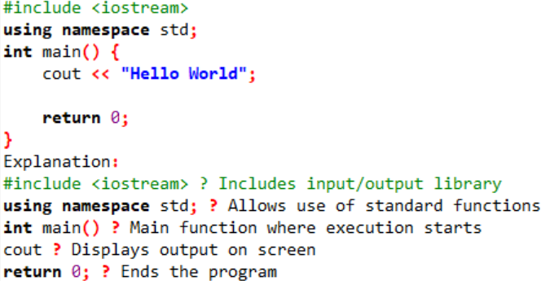
Output:
Hello World
Result:
The Dev-C++ IDE was successfully installed, and the first C++ program was compiled and executed correctly.
Conclusion:
We learned how to install Dev-C++ and run a basic C++ program. This is the first step toward learning programming
Lab Task
Code: 01
